Tethered Power System for Drone

User Manual

LG55 LG70
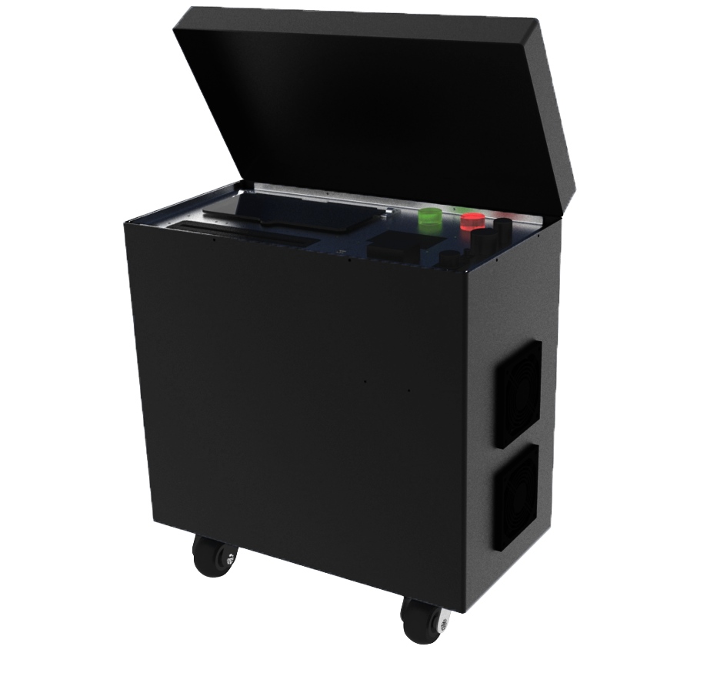

Contents

Contents 2
Read The Instructions 3
General Use 4
Open The Box 4
Product list 5
Before use 6
Taking off 7
Landing 9
How to use fiber connection 12
Transportation 13
Operation warnings 13
Technical data 14

Read The Instructions
- It is recommended to read the Quick Guide sticker before first time use. Prepare for your first flight by reviewing the User Manual for more details.
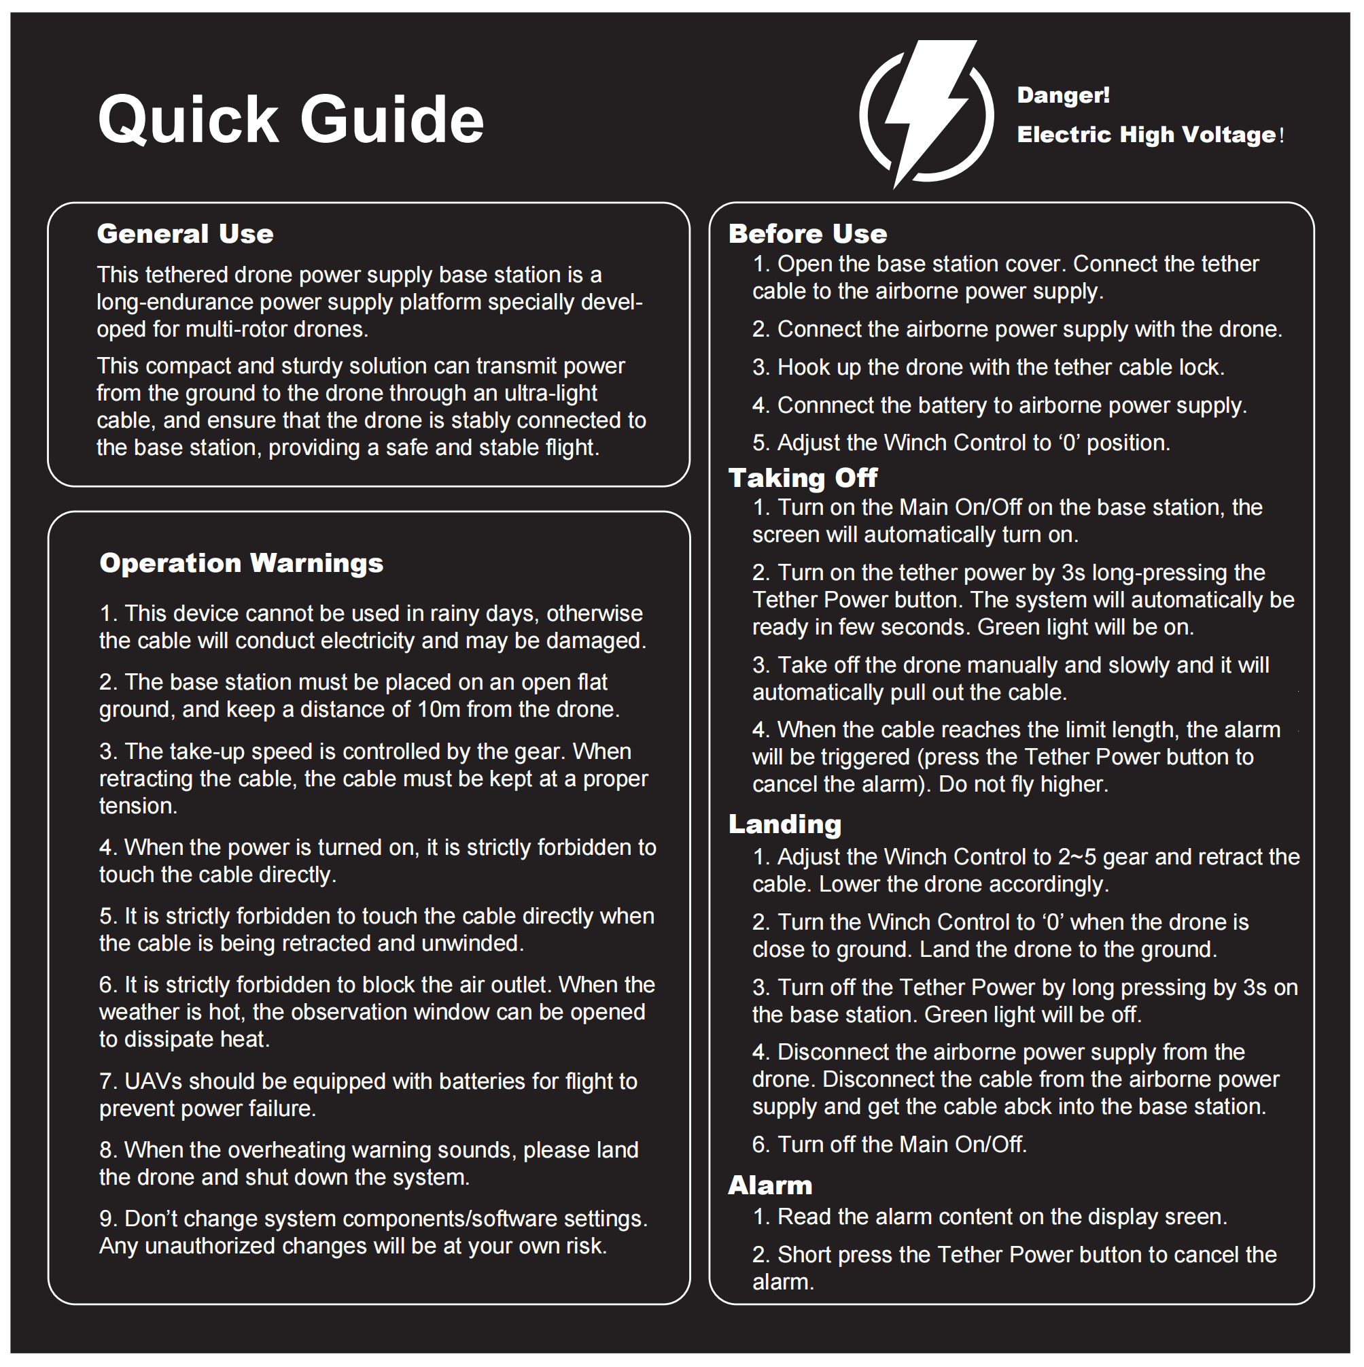

General Use
LG55/LG70 is a rugged tethering station for multi-rotor drones. This compact and robust solution enables the transmission of power from an external ground power supply unit to the drone through the micro-tether. The core of the micro-tether ensures the drone remains attached to the base station providing a safe phase of flight.

Open The Box
1 x LG55/LG70 All-in-one base station 420V / 750V DC output | 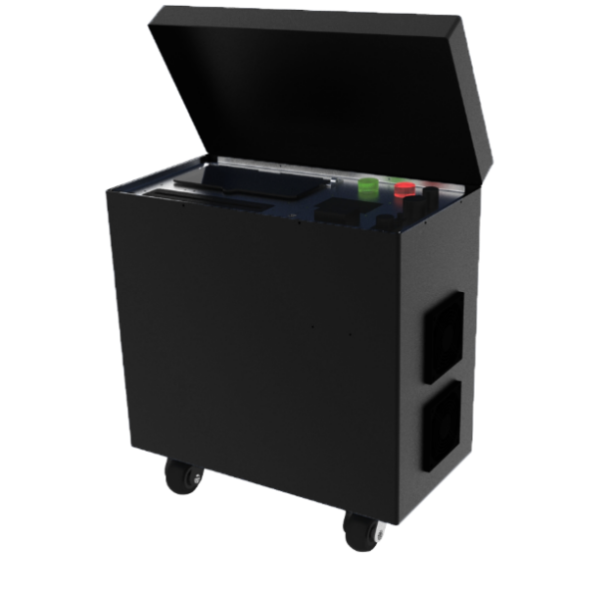
1 x 12S / 6S airborne power supply | 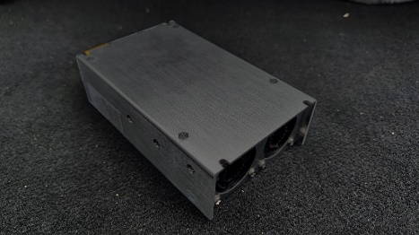

Product list
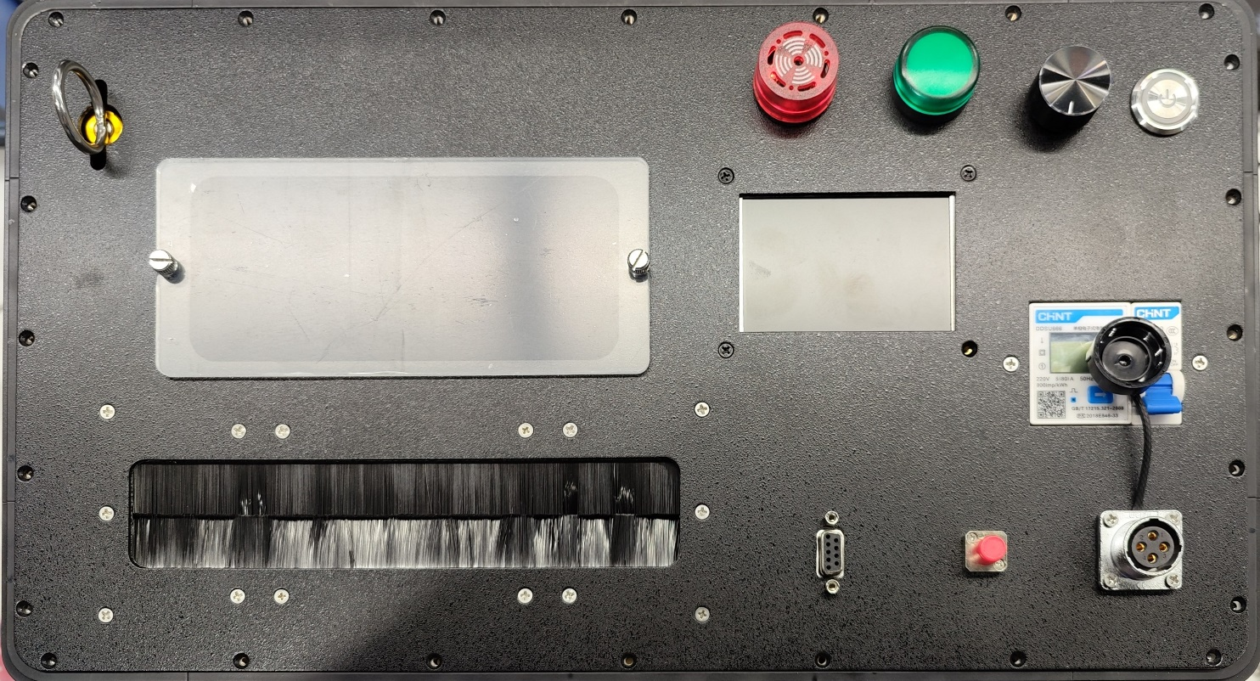
Display Screen
Observation Window
Cable Rod
Fiber Optical
Main ON/OFF
Power Input
Alarm
Air Power Indicator
Winch Control
Tether Power
The ground station user interface includes below controls.
- Power Input: The power input should be connected to 220V~50Hz. An emergency, unplugging the cable can cut the power supply to the station.
- Main ON/OFF: When it is activated, the station will work but NO power is to the tether cable to secure the safety of users.
- Tether Power: ON- power to the cable. OFF- power off the cable.
- Long press for 3s to power on.
- Long press for 3s to power off.
- Short press to release the alarm.
Attention. Serious injury could occur if the micro-tether is manipulated once the power is switched ON.
- Winch Control: It can control the winching speed of the tether.
- Fiber Optical: It can be used to transfer data via the cable with the drone.
- Alarm (Red): The buzzer alerts the user to an alarm. The alarm content will be displayed on the screen.
Attention. Short press the Tether Power button to release the alarm.
- Power (Green): Long press the Tether Power button so as to ignite the power to tether cable. This green light will be on, which means the power is transferred to the cable.
- Observation Window: To observe the status of tether cable. It can be open up if the environment temperature is above 35 ℃.
- Display Screen: To display information such as, current, voltage, temperature, cable length released and alarms.
- Airborne DC-DC converter(different air power module varies in details)
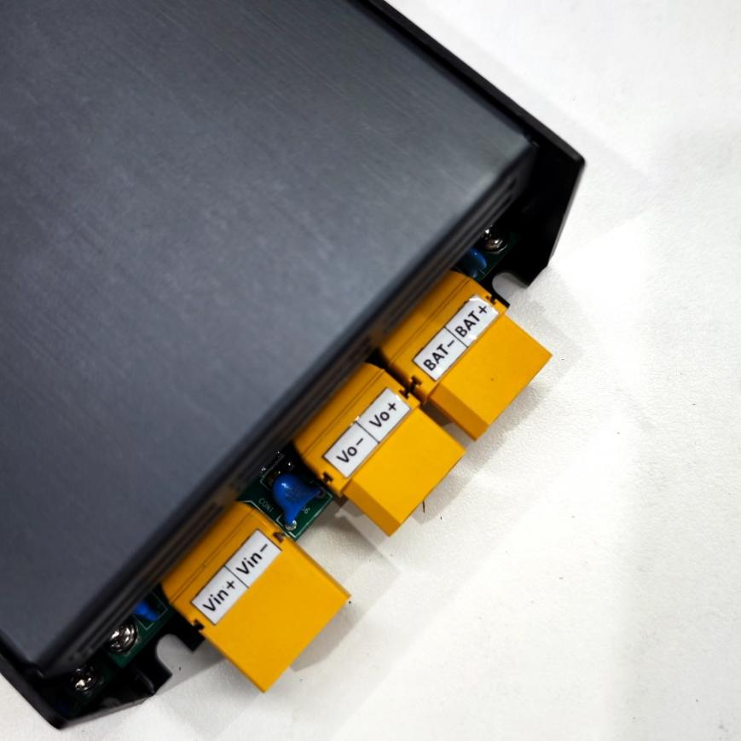 | BAT+ / BAT-:  Contact this to airborne battery as backup power supply  Vo+ / Vo-:  DC output from this power supply which should be connected to UAV power  Vin+ / Vin-:  DC input from base station tether cable

Before use
- Open the base station cover. Turn on the System On/Off on the base station, the screen will automatically turn on;
- When the screen displays "Power OFF", pull out the tether cable to start the normal meter counting.connect the socket to the airborne power input. Connect the airborne power supply with the drone. Connect the backup battery to the airborne power supply
- Adjust the winch control to the "0" position on base station. If not, the alarm will be on.
- Attention. Please start the generator and wait for 3~5 minutes，The generator's power output must be at least 1.5 times the power requirement of the tethered airborne module.
- Screen display description
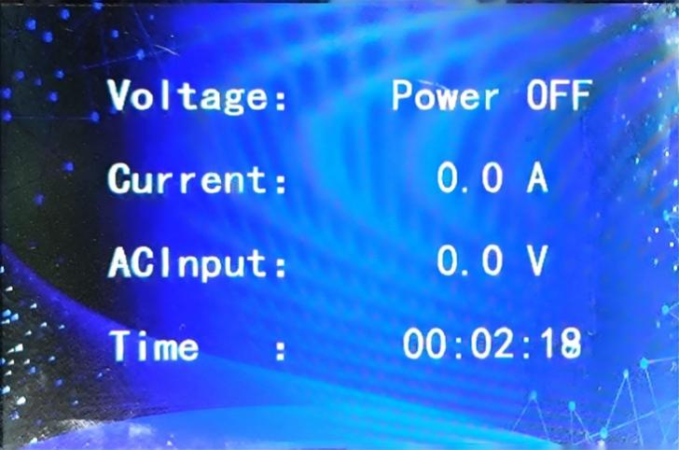 | Voltage-Tether power off or Tether Power voltage  Current-Tether current to Drone  AC Input-AC input voltage  Time-Working time
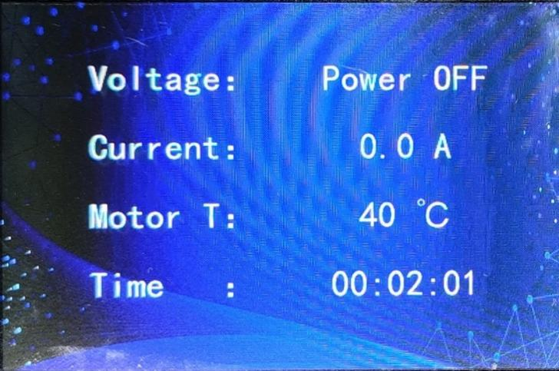 | Motor T-motor temperature
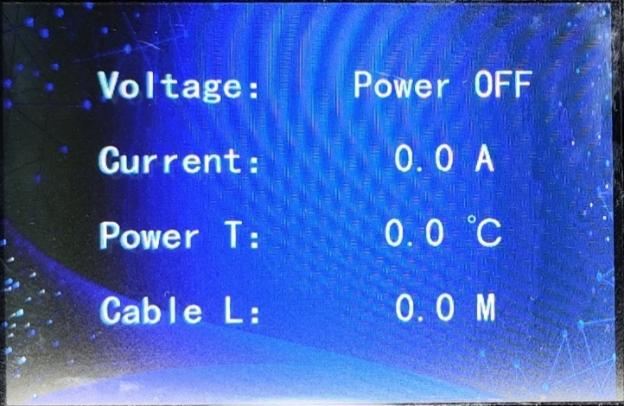 | Power T-Power temperature
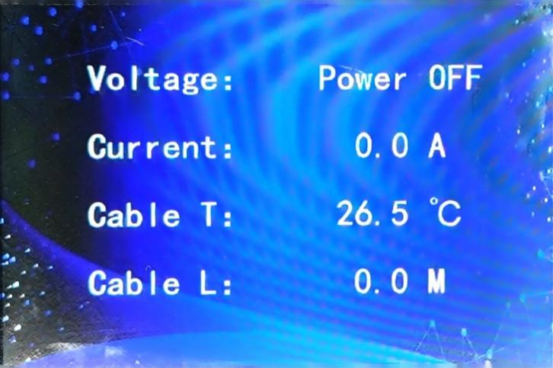 | Cable T-Cable temperature  Cable L-Tether out

Taking off
- Long press the Power Switch for 3s to turn on the tether power. The system will automatically be ready in few seconds. The green light will be illuminated to indicate the tether power is on. You can read the increasing voltage data on the screen.
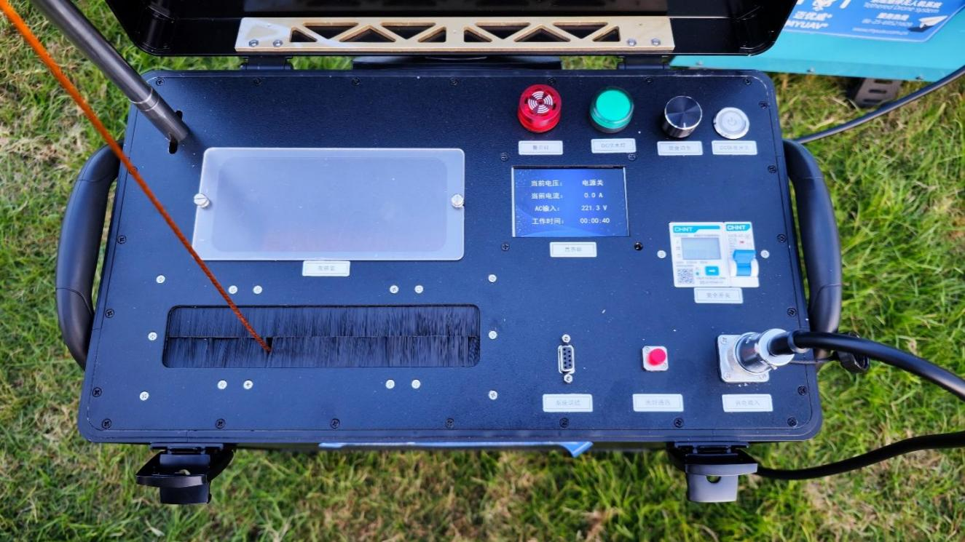

- Attention. Please watch the green light on during the drone is hovering. If the green light is off, it means the tether power is off. The drone is powered by the battery now.
- Take off the drone manually and slowly and it will automatically pull out the cable.
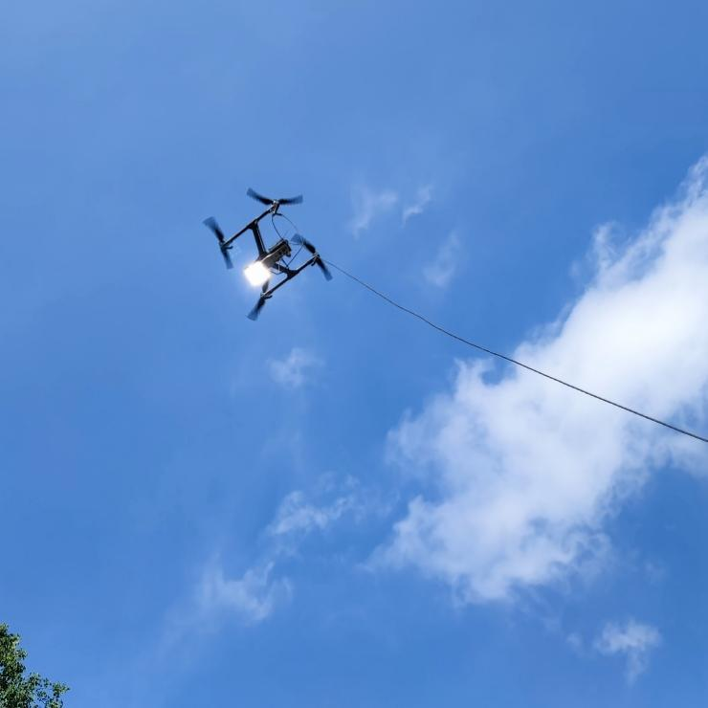
- Attention. Please take off the drone slowly in case of pulling the tether too hard. It may cause unbalance of drone and drop-down may occur.
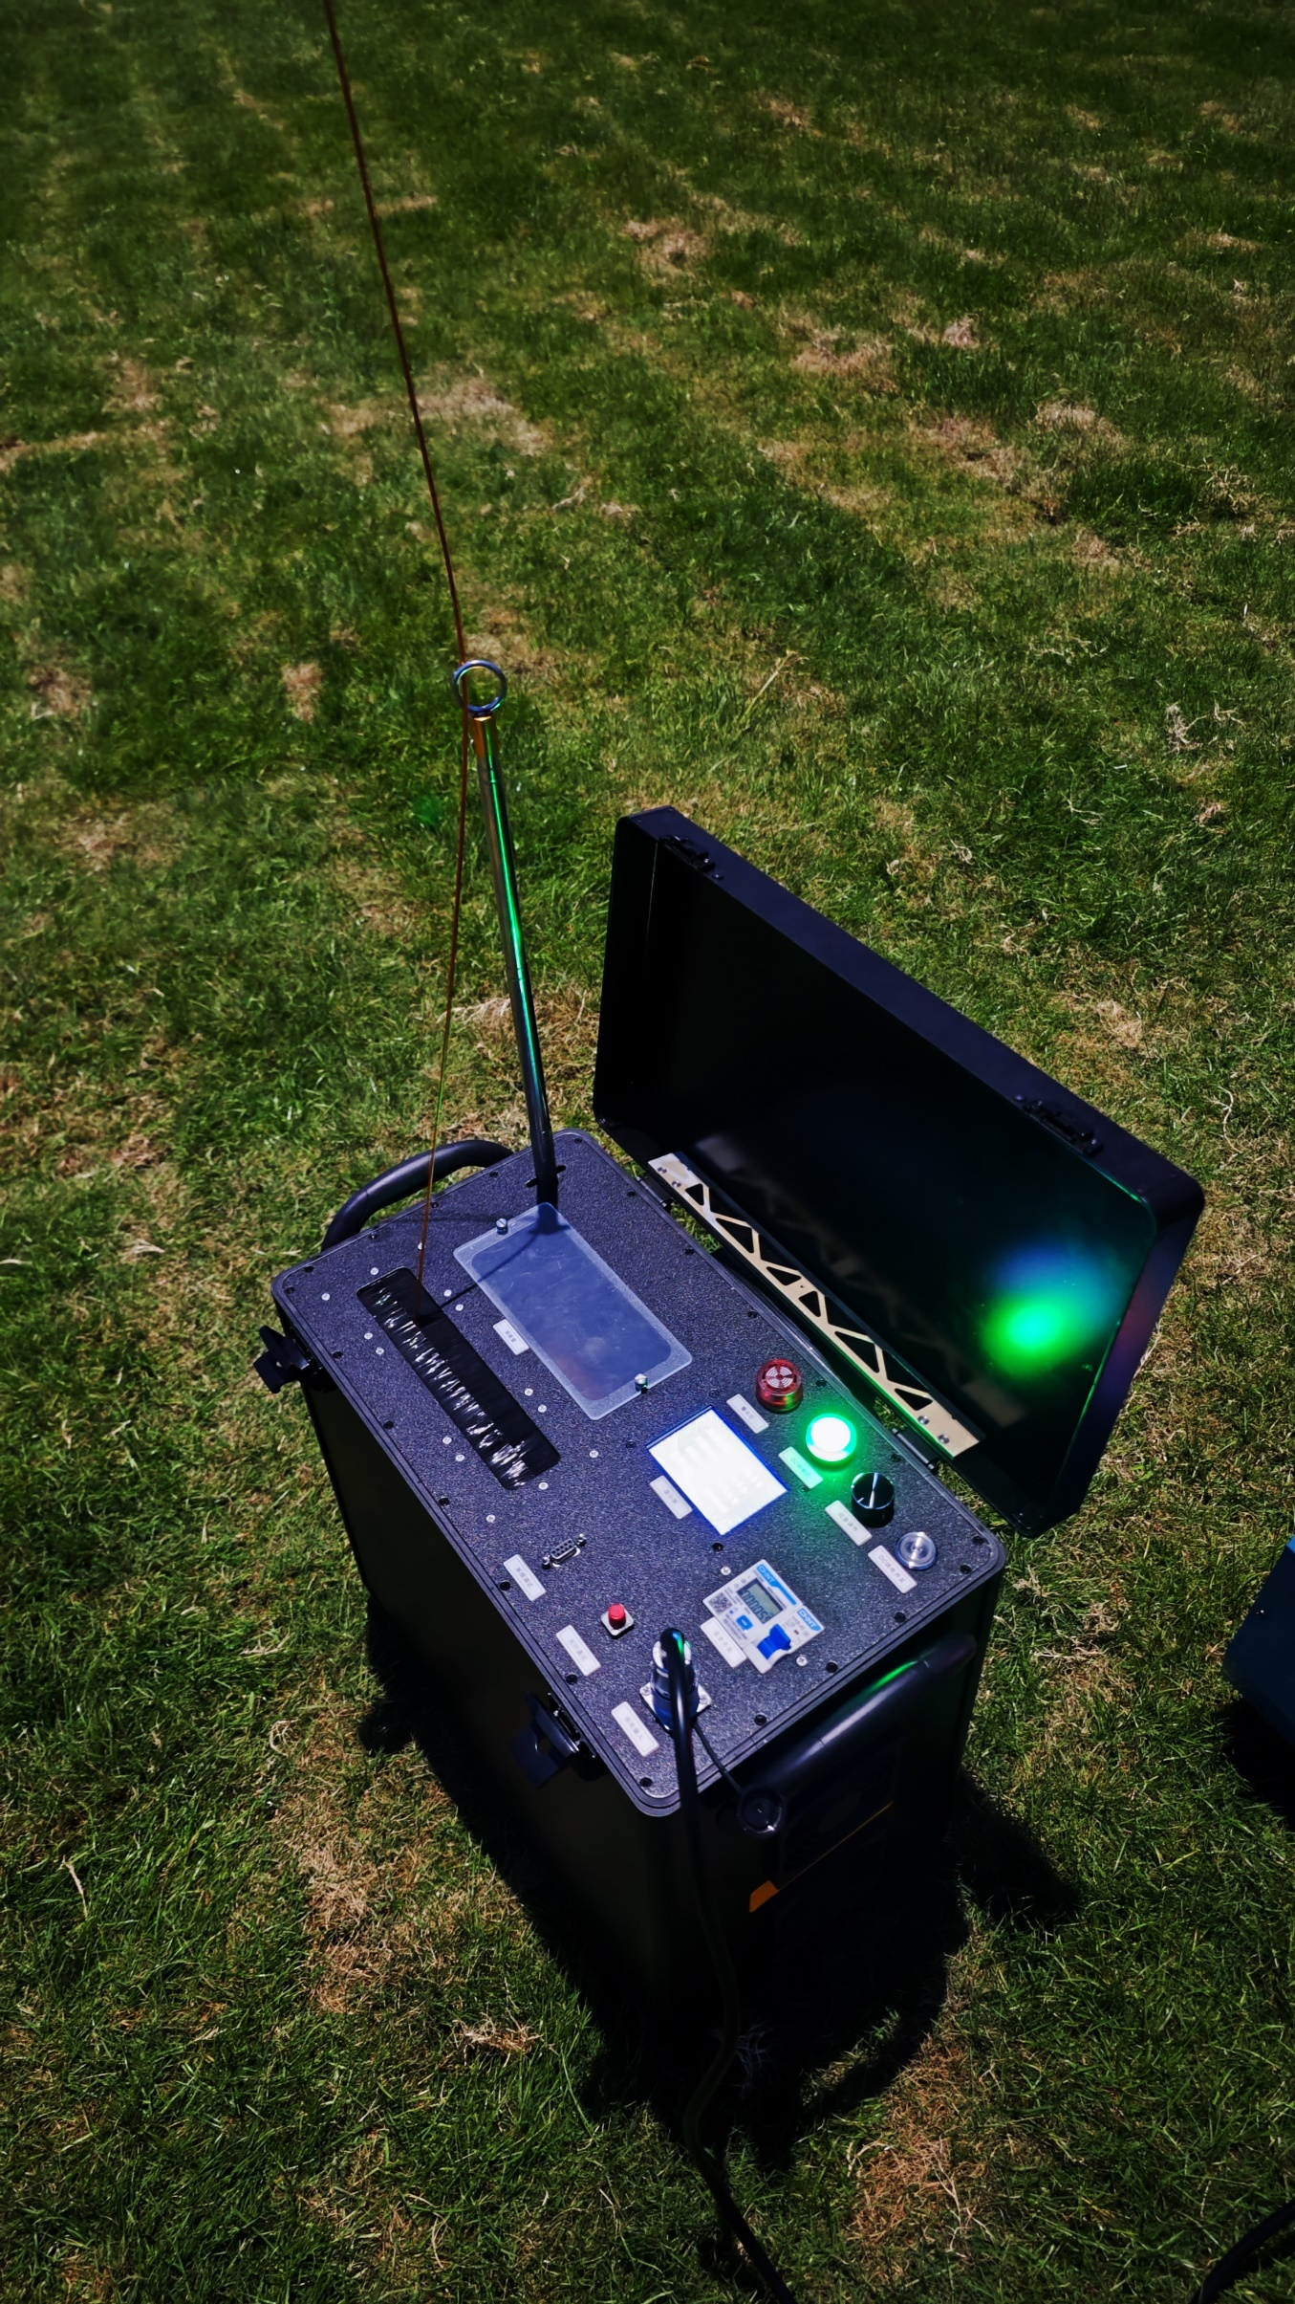
- Attention. For inside cooling, the observation window must be open, and release the tether cable more than 80% of the total length.
- When the cable reaches the warning length, the alarm will be triggered (press the power switch, the alarm will be cancelled). Do not fly higher. Lower the drone.
- Attention. Watch the tether through the observation window if needed.

Landing
- Adjust the Winch Control and lower the drone at the same time to retract the cable(Note: When the drone is hovering, ensure the tether cable maintains proper tension based on actual conditions. Typically, adjust the winch within gear level 0–1. During landing, maintain a certain tension on the tether as well—usually set the winch to around gear 1, or coordinate the landing between the pilot and the winch operator.
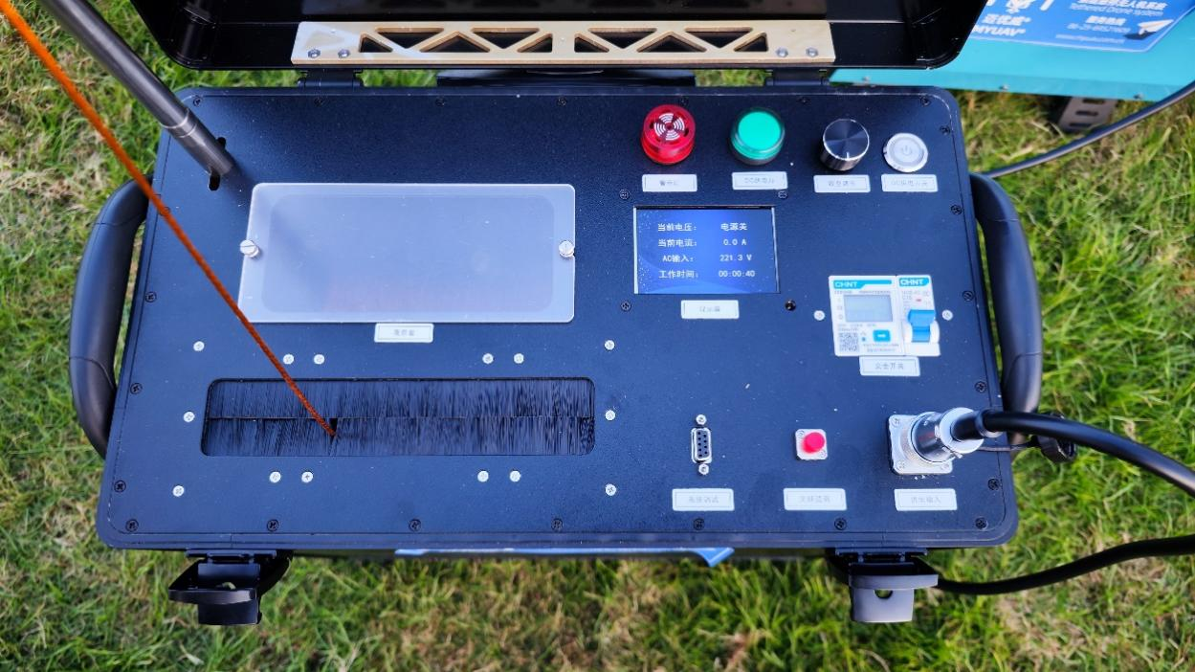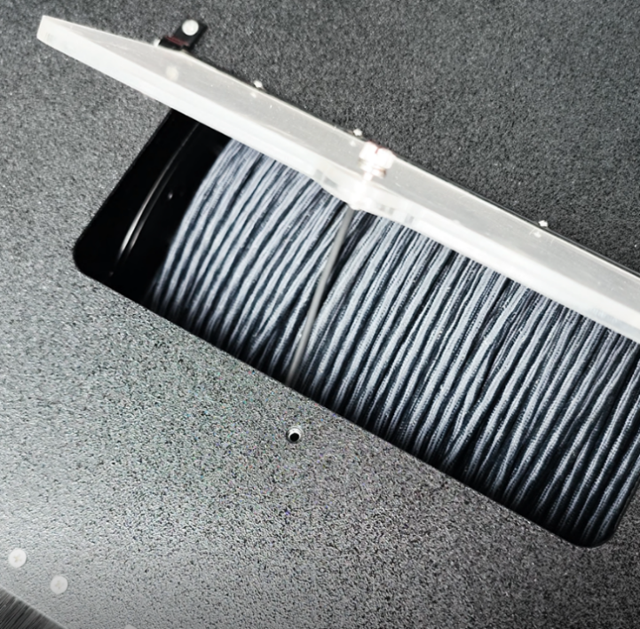

- Attention. Watch the tension of the tether. Keep the tether not too tight in case of drop-down of the drone.
- Turn off the Winch control when the drone is close to the ground. Land the drone to the ground.
- Attention. Do not touch the tether before the power switch is turned off. Electric shock may occur if the tether is broken.
- Long press and turn off the Power Switch on the base station. The green light will extinguish and you can see the voltage on the screen goes to ‘Power OFF’. The tether power will die away in seconds.
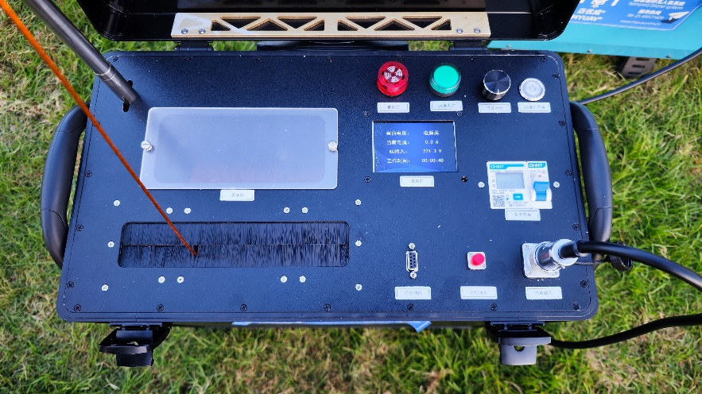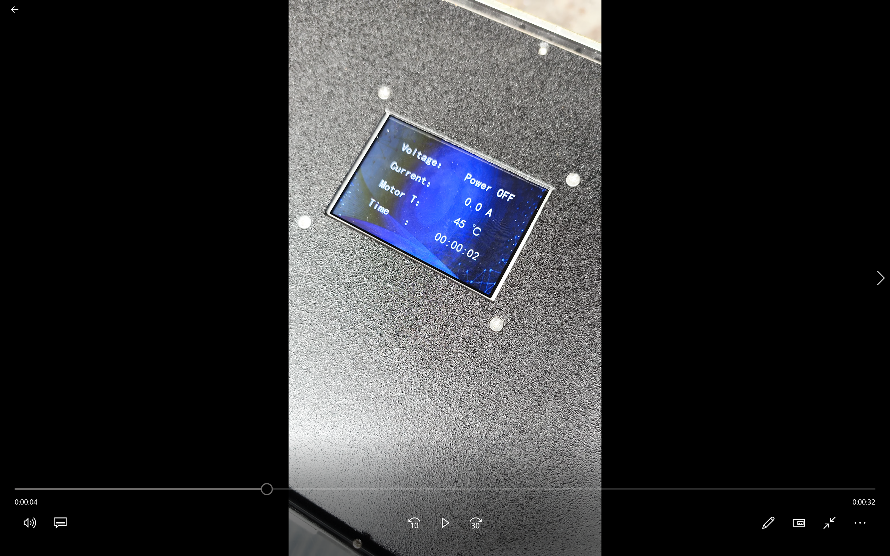
- Disconnect the airborne power supply from the drone. Disconnect the cable from the airborne power supply.
- Retract the rest tether before you switch off the Safety On/Off.
- Attention. Cut off the power of the station. Then disconnect the cables.

How to use fiber connection
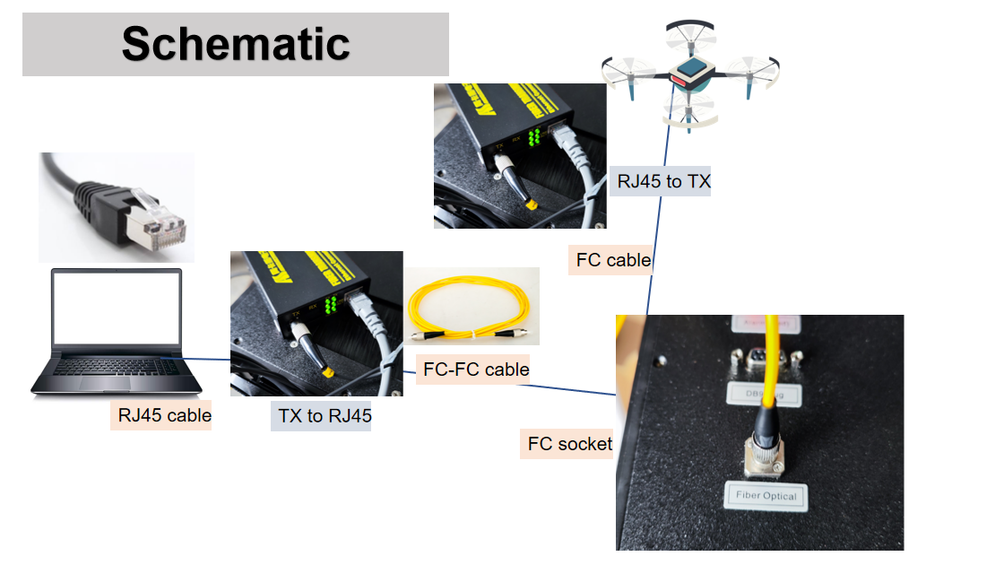
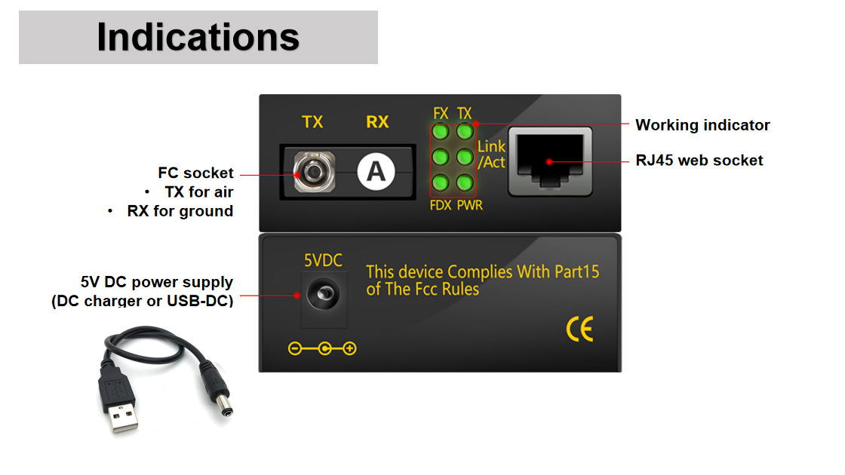

Transportation
No bumping and water entering during the transportation of this equipment. It must be packed in aviation aluminum box during transportation or take damping treatment, or the warranty does not cover.

Operation warnings
- This device cannot work on rainy days, otherwise the cable will conduct electricity and may be broken.
- Put the base station in open flat ground and leave at least 10m distance away from the aircraft.
- The cable pulling speed is controlled by winch control. When releasing/pulling the cable, you must keep the cable in a suitable tension to prevent winching and pulling the aircraft.
- No touching the cable directly when the power is on.
- No touching the cable directly when it is moving.
- Blocking air outlet is strictly prohibited. The observation window can be opened for heat dissipation when hot.
- The aircraft should be equipped with battery in case of power-off.
- When the overheating warning is ignited, please withdraw the aircraft and shut down the system in minutes.
- Do not change the system components/software settings. Any risk caused by unauthorized change will be covered by yourself.

Technical Specifications
 | LG55 / LG70
Input | 220-230V~ 50/60Hz
Output | Base station 5.5kw /7kw max.
Max.Height | 120m max.
Cable | Optical / electric only
Power compensation | Auto
Optical com | Yes
Anti-shock | Yes
Material | Aluminum
Size | 46.5x24x44 cm outer size / 22‘ suitcase
Outer box size | 50*63*65cm LxWxA
N.W. Weight | 24kg

